GIT HUB Task -2

- Install git.
- Git already installed
- Use Command: git --version
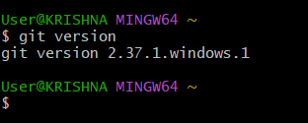
- Create a repo in github with README.md and .ignore file.
- I have created an cloud_tech respository in github with readme.md and .ignore file
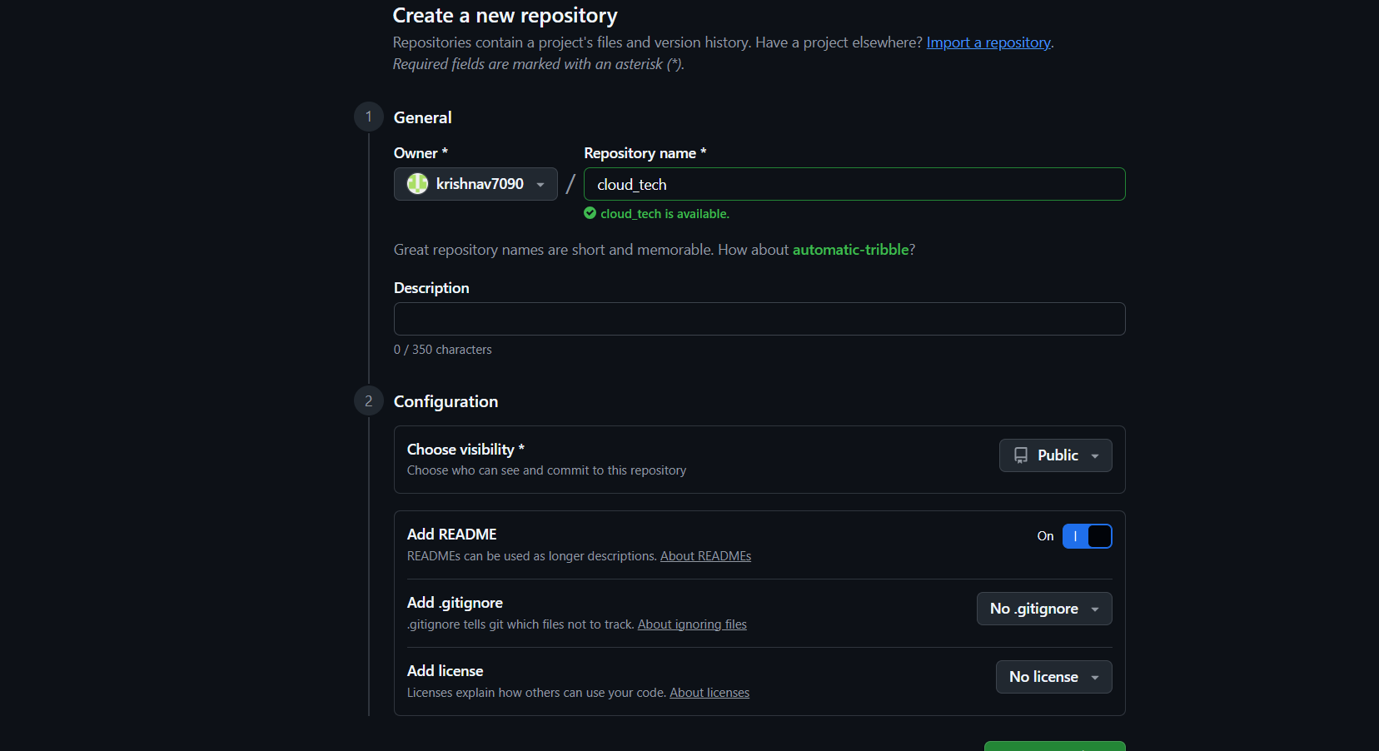
- Clone the created repo to local.
- First went to github and copyed url https
- In gitbash inside an directory type command git clone paste the url and enter.
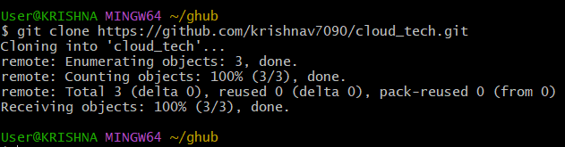

- Create two files in local repo.
- Created two files sahith, krishna in local repository using touch command
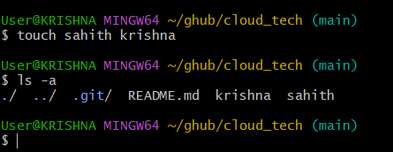
- Commit two files and push to central Repository.
- I already have files krishna and sahith, now use git status to the files whether its in untracking are in tracking
- Now, using git add files names it will start tracking. Git commit -m “added file names”
- Now, use push command git push origin master
- Now, go to github refresh the page and we can see added files.
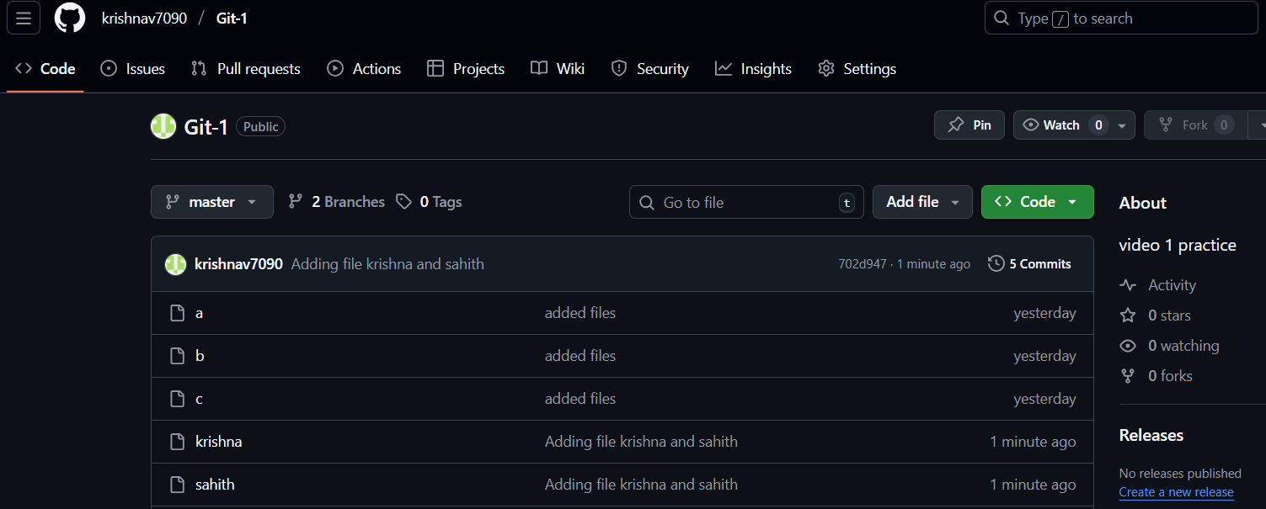
- Create a branch in local and create a sample file and push to central.
- First create new branch in local repo using command git checkout –Testing
- Now, created an file vikas, using command git add vikas.
- Now use command git commit -m “added file vikas in Testing”
- Now, use command git push origin Testing. Now, we can check it in github . Testing branch has been created with file.
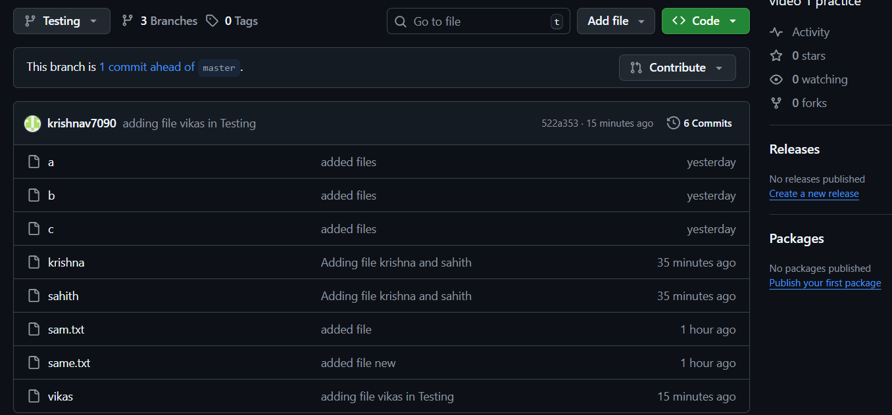
- Create a branch in github and clone that to local.
- In git repository, select new branch and created coding branch. Create an file in it called python_code.
- Using command git pull > git checkout coding > ls .
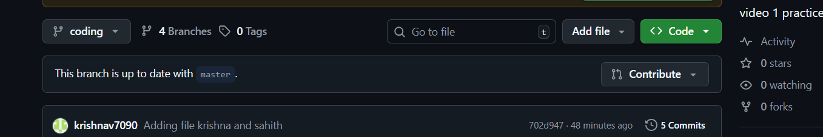
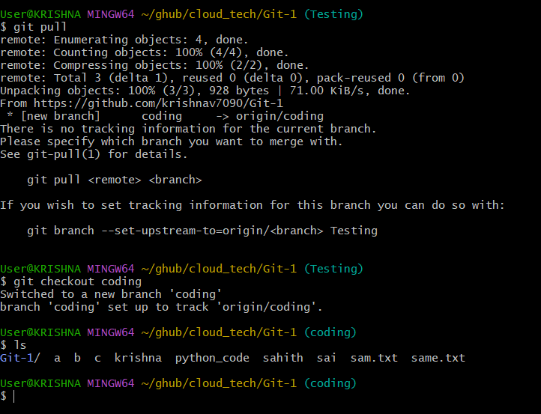
- Merge the created branch with master in git local.
- First checkout from path. So, I switched to testing. Git checkout Testing
- Use command git merge master and now it will be merged
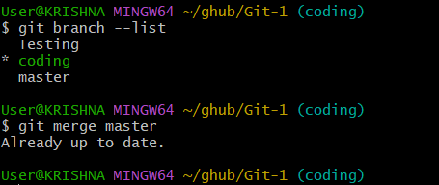
- Merge the created branch with master in github by sending a pull request.
- In github created pull request and merged coding to master
- Merged successfully
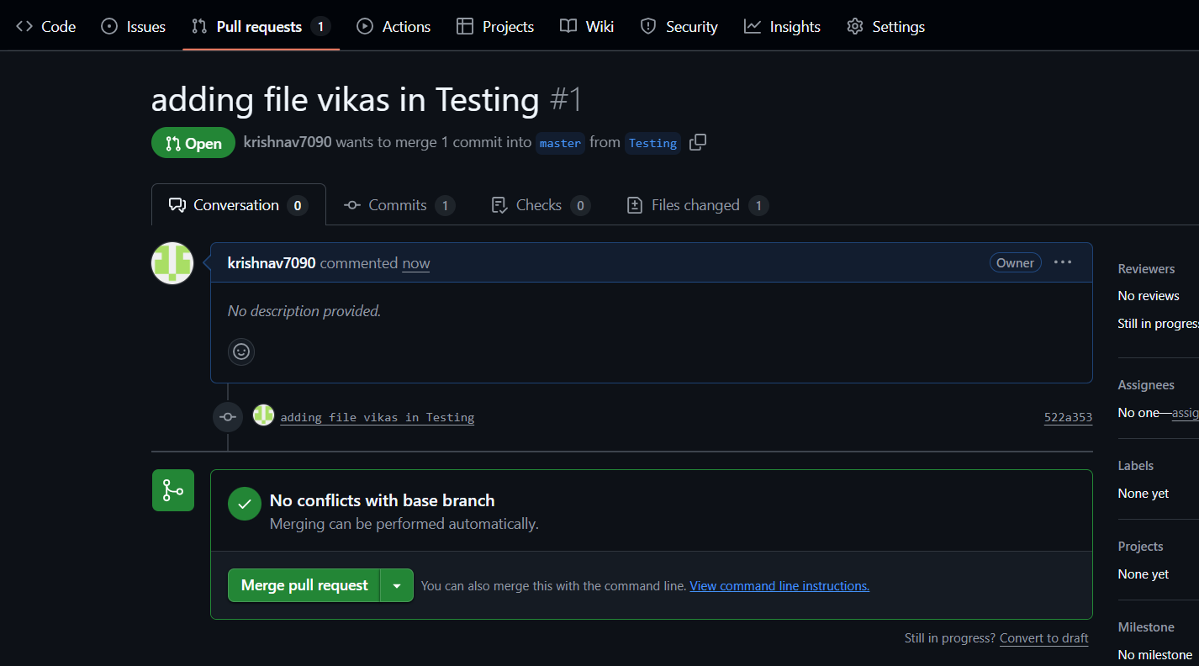
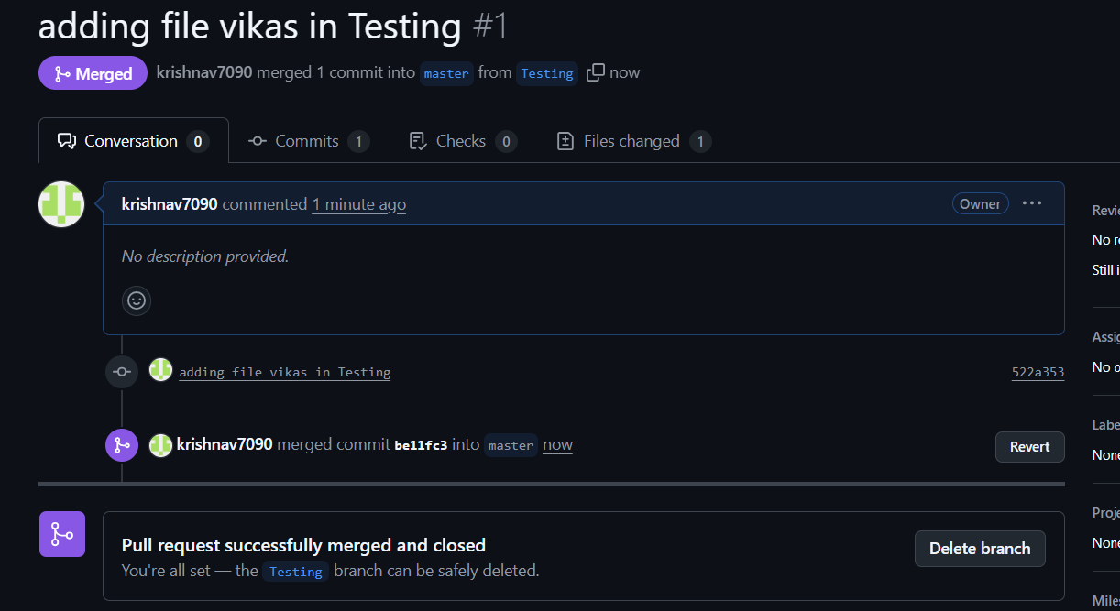

- Create a file in local and send that to branch in github.
- Created an file names Store using touch command and used git add store to move to tracking
- Used command git commit -m “comment”
- Now using git push moved data from local repo to github
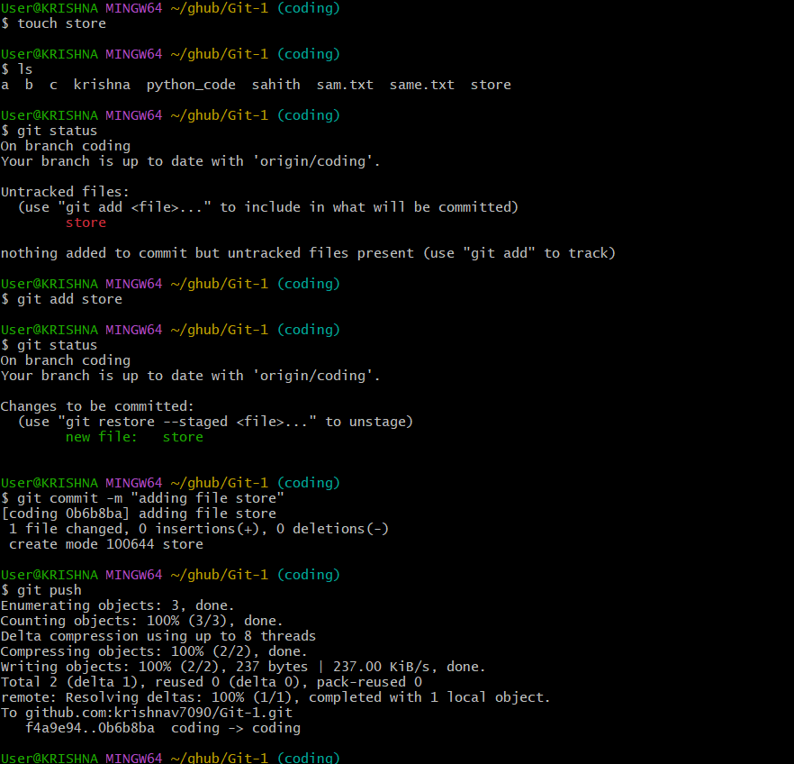
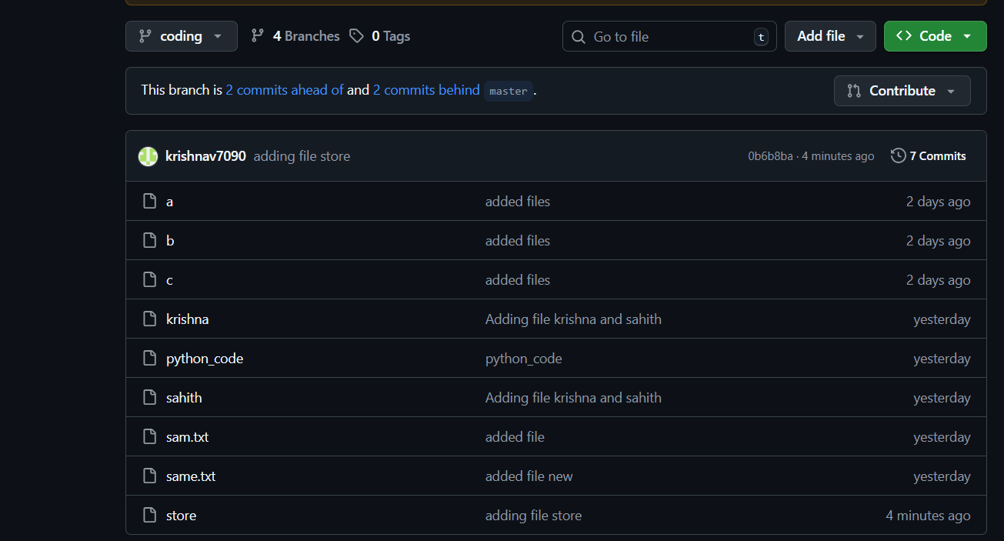

- Clone only a branch from github to local.
- Use command “git clone -b (branch name) ssh url”
- Branch name Testing and copyed ssh url from remote repository.
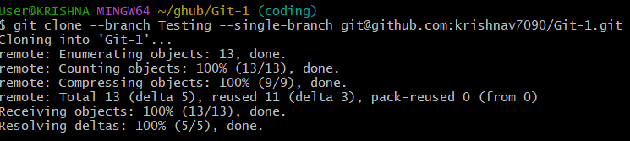
- Create a file with all passwords and make that untrackable with git.
- Create a file password and added some details in that file.
- now create vi .gitignore and add the file name what you want to hide (password).
- Then add that .gitignore file and commit and push to central repo.
- In github the .gitignore file will be shown and in that the hidden file will be show but the
details in the file will be not show.
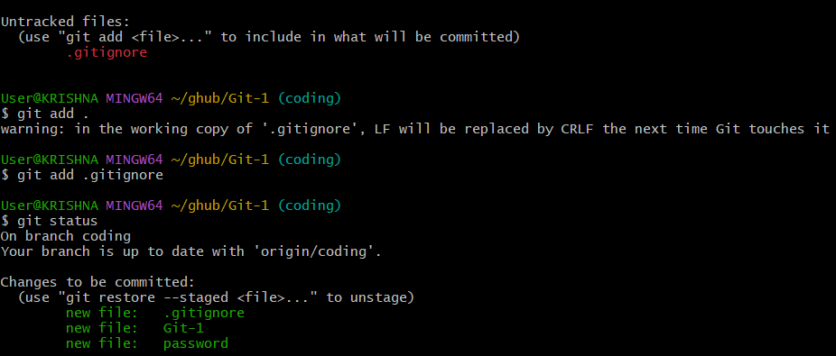
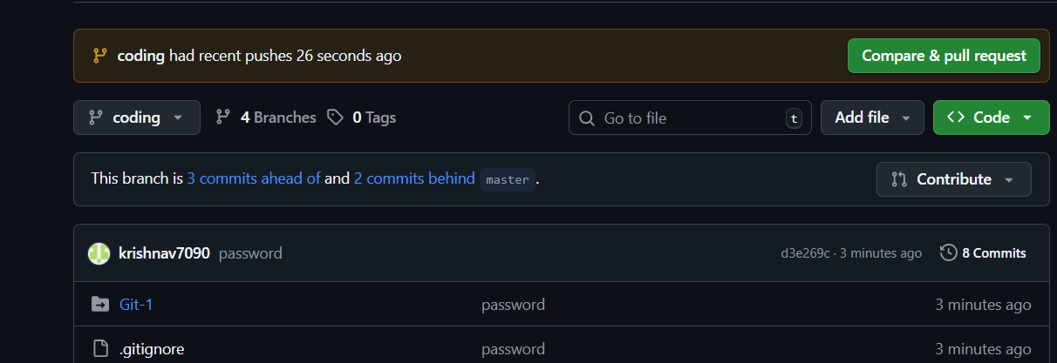
- Make a commit and make that commit reset without savings changes.
- Created a file named tech and used git add tech and checked the status and now its added
- Now I want to get back back by using git reset tech.
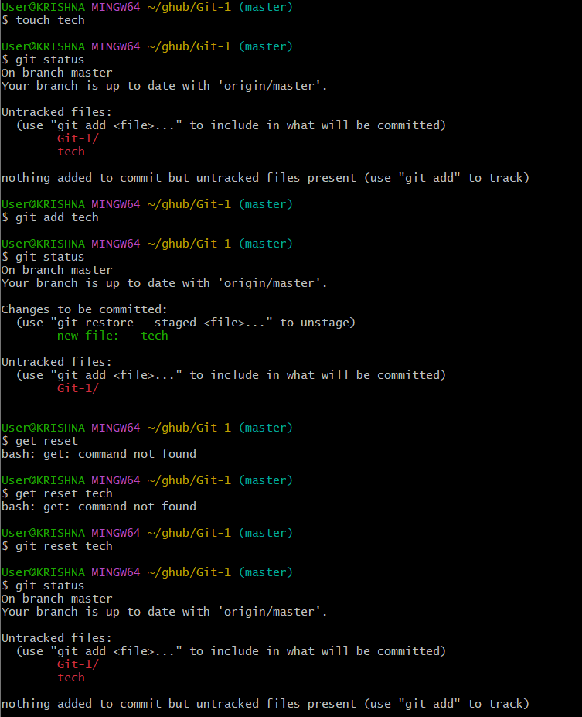
- Revert a commited commit to the older version.
- Using git log command to check commited id. Now using command git revert “add first 5 digits of commit id”
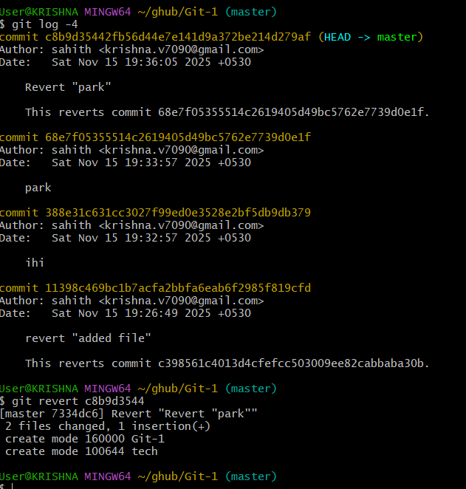
- Push a file to stash without savings the changes and work on another file.
- Created an file using touch command ‘temp.txt’. checked the status using git status.
- To moved file to tracking using git add . . now use git stash and check the status.
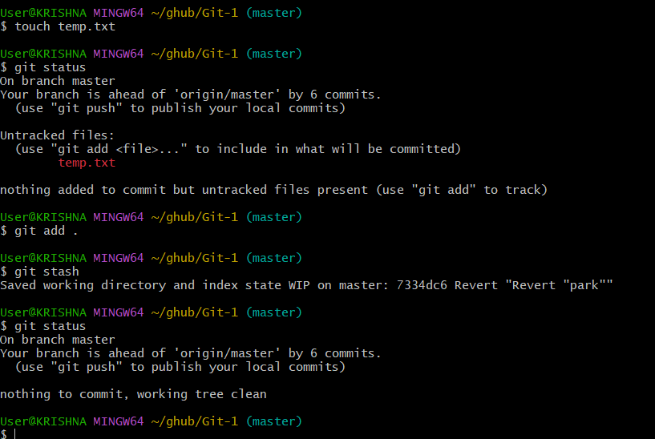
- Undo the stash file and start working on that again.
- Using command git stash list we can check and now using git stash pop we can bring the file out.
- We can check that whether the file moved back or not using git status
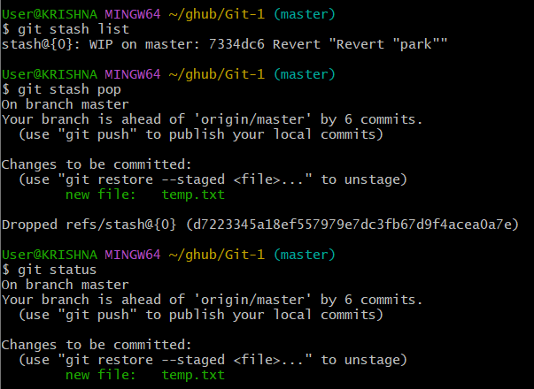
- Generate a ssh-keygen and configure into github.
- Use ssh-keygen enter
- Copy the link and paste it in the github
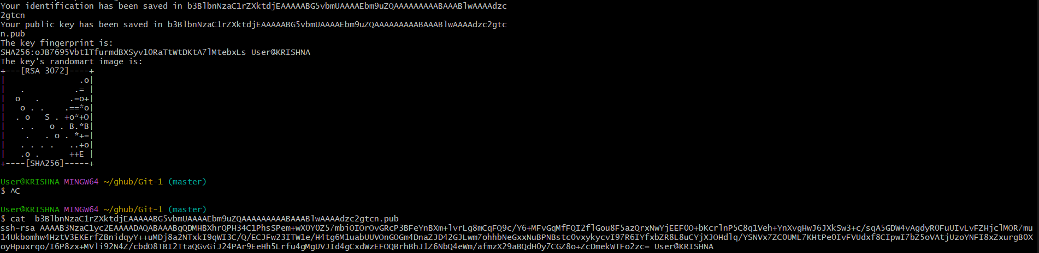
- Configure webhooks to github.
- Basic understanding of .git file.
- . git is a hidden folder created when we use git.

- It contains all git data for our project. It stores our commits, branches, and history.

- It keeps track of changes we make in files.

- If you delete .git, your project stops being a git repo.

- It is like the brain of git for your project

- Check all the logs of git.
- We use command: git logs
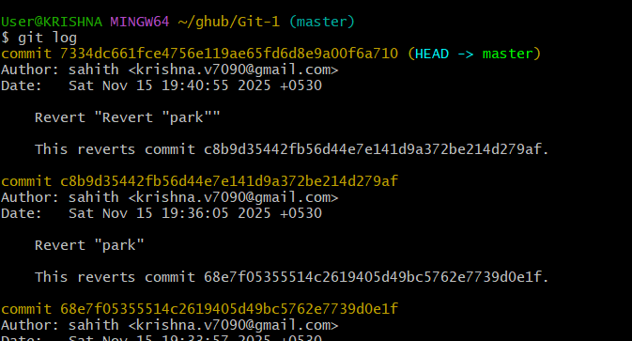
- Rename the commit message.
- Using command: git commit –amend. Change or rename the message and exit
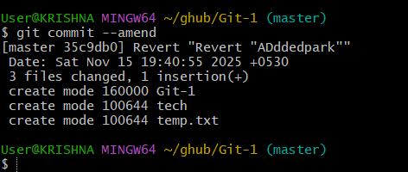
- Merge multiple commits into single commit.
- Using command: git rebase -I head~4 we can merge commits into single commit.